**Document Type: QA Test Result**

Report Name: **9C_C_03B Receive Summary**

Tester Name: Md. Amin Khan

Test Date: 24-10-2023

**Browser**: Microsoft Edge

**Through API: Date: 20-11-2023(Postman)**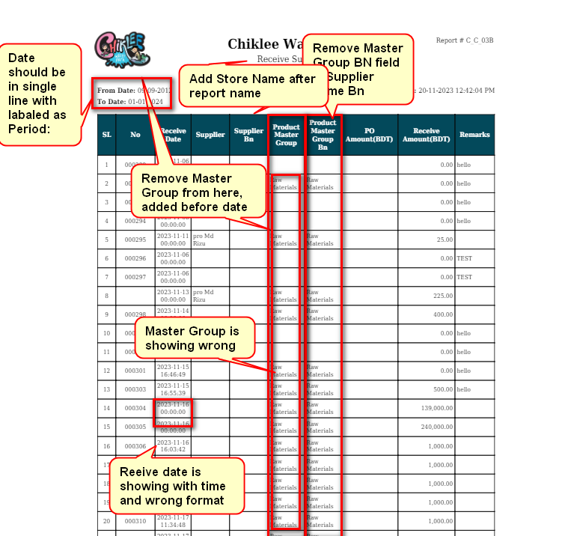

1. Add Store Name after Report Name
2. Date should be in single line and Replace Date label name to “**Period**”
3. Remove Product Master Group from column, add in first row and data grid should show same master group wise[ Follow Item Stock Report for design]
4. Master Group is showing wrong
5. Remove Product Master Group BN column
6. PO Amount9BDT) is not showing
7. Receive Date is showing with time and wrong format, Actual format = dd-mm-yyyy

In UI:

1. Data is showing from Receive Master that haven’t GRN Number, It should show from Receive Master but Must Have GRN Number.
2. Receive Date should show only Date, Format: dd:mm:yyyy

In PDF:

1. Add Product Type & Master Group bellow of “To Date” and Data should show Product Type & Master Group wise, like stock report.
2. Receive Date should show only Date, Format: dd:mm:yyyy
3. Rename From Date & To Date to “Period” and date difference should be handle by in single line with middle of “to” like: 
4. Add more width for Supplier Name & Supplier Name 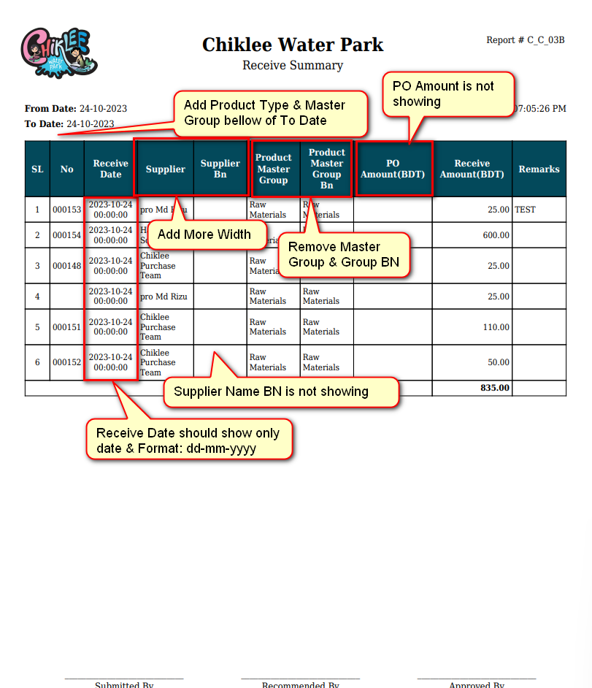
5. Remove Master Group & Master Group BN from field, it will be handled by top of the grid.
6. PO Amount is not showing